Assignment

Name: - Mylarapu Ravi

Ph. No: - 6302540471

Batch: - 119

E-Mail: - [ravimylarapu39@gmail.com](mailto:ravimylarapu39@gmail.com)

Assignment: - load balancer

1.first create security groups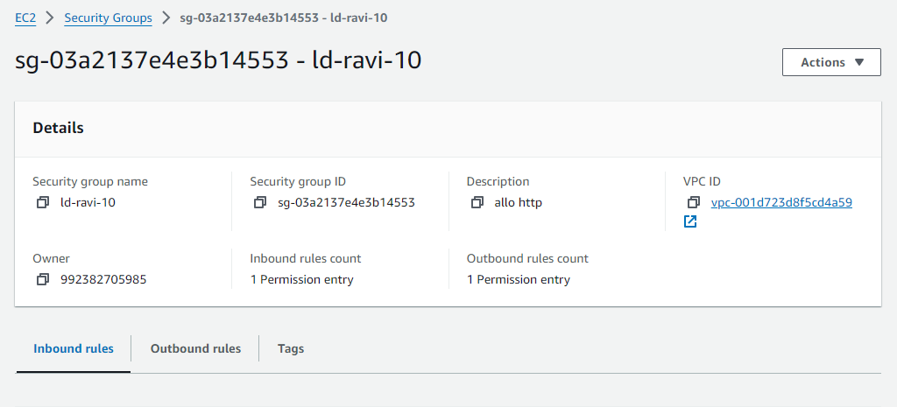

2.next create 2 ec2 enstance 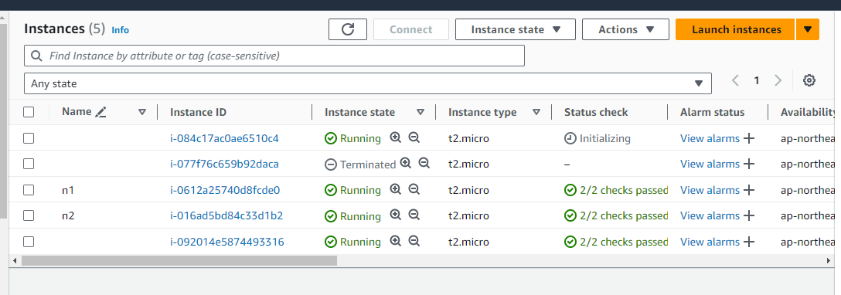

3.next launch instance and install nginx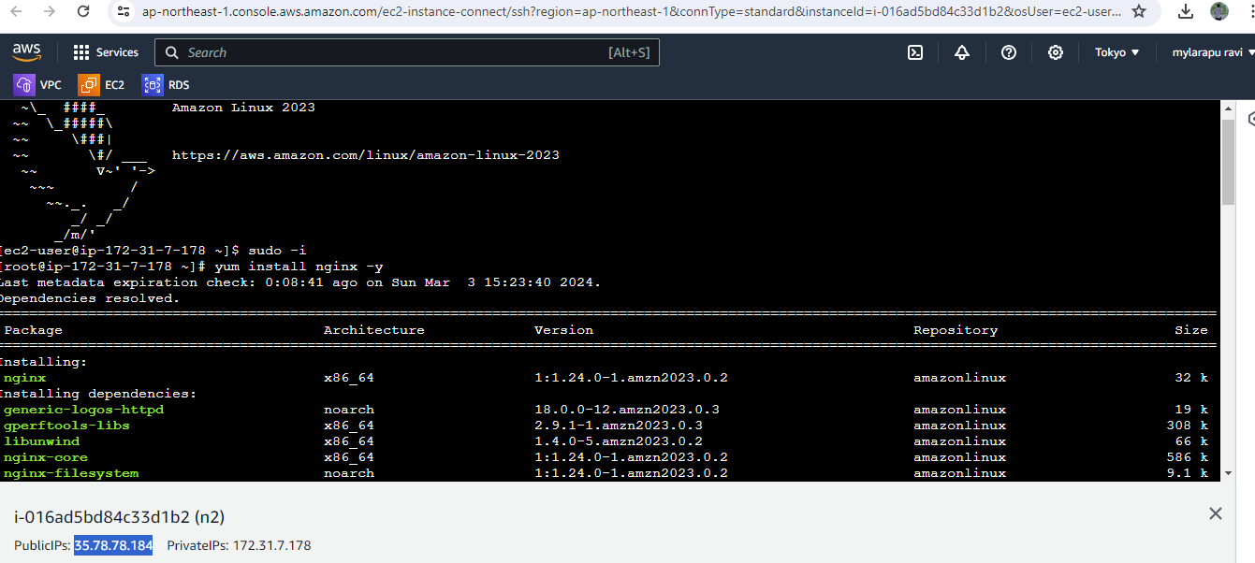

4.ofter installation copy the public ip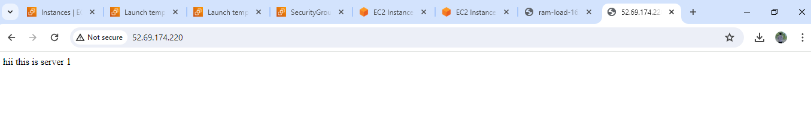

5.next create another instance and launch it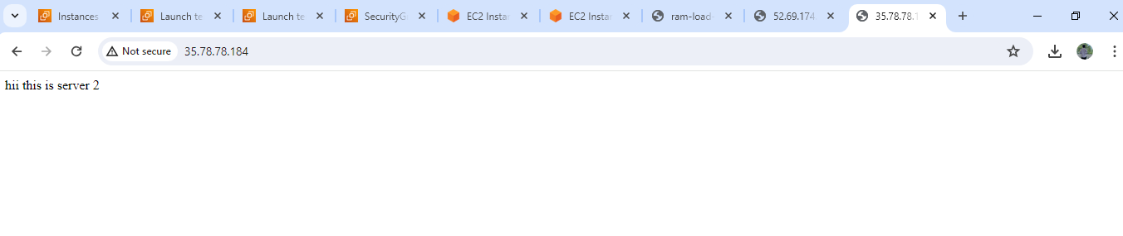

6.nex go the target groups and create it 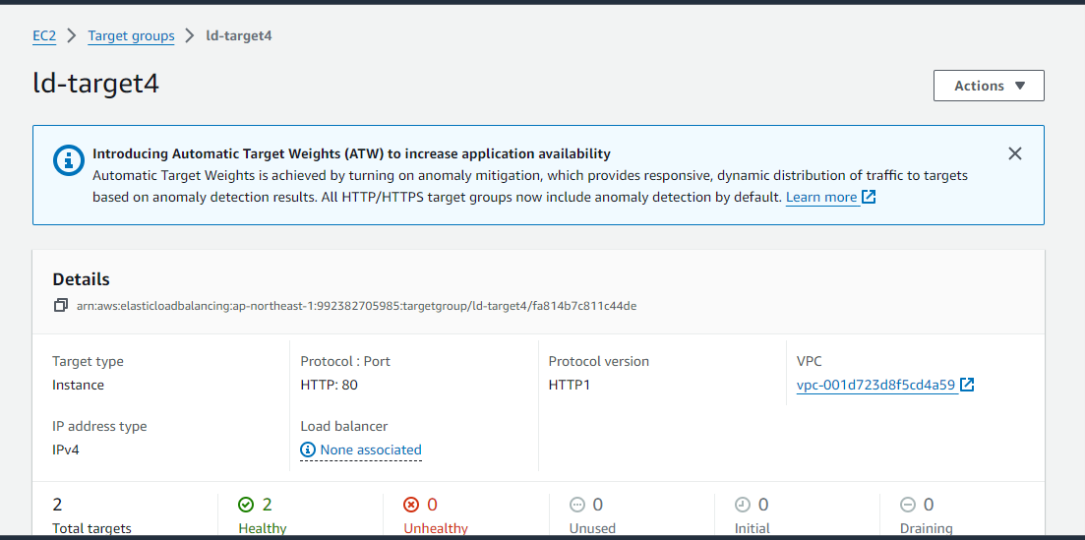

7. next go the load balancer and attached security groups and copy the load balancer ip and paste it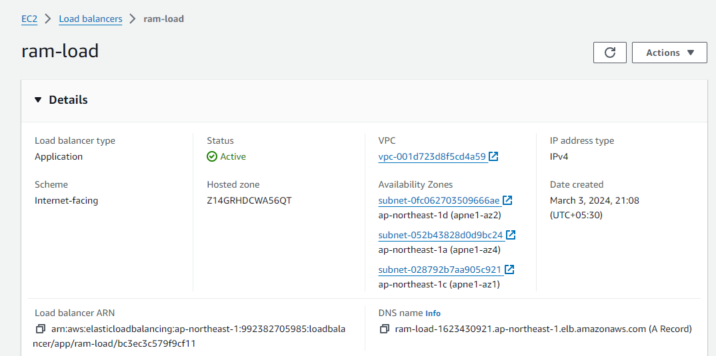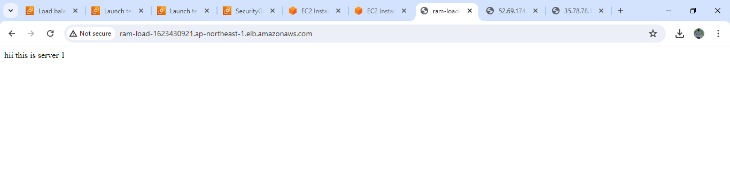

8. done

Auto scalling

9.next move to auto scalling groups